Human Rights Grants Scheme
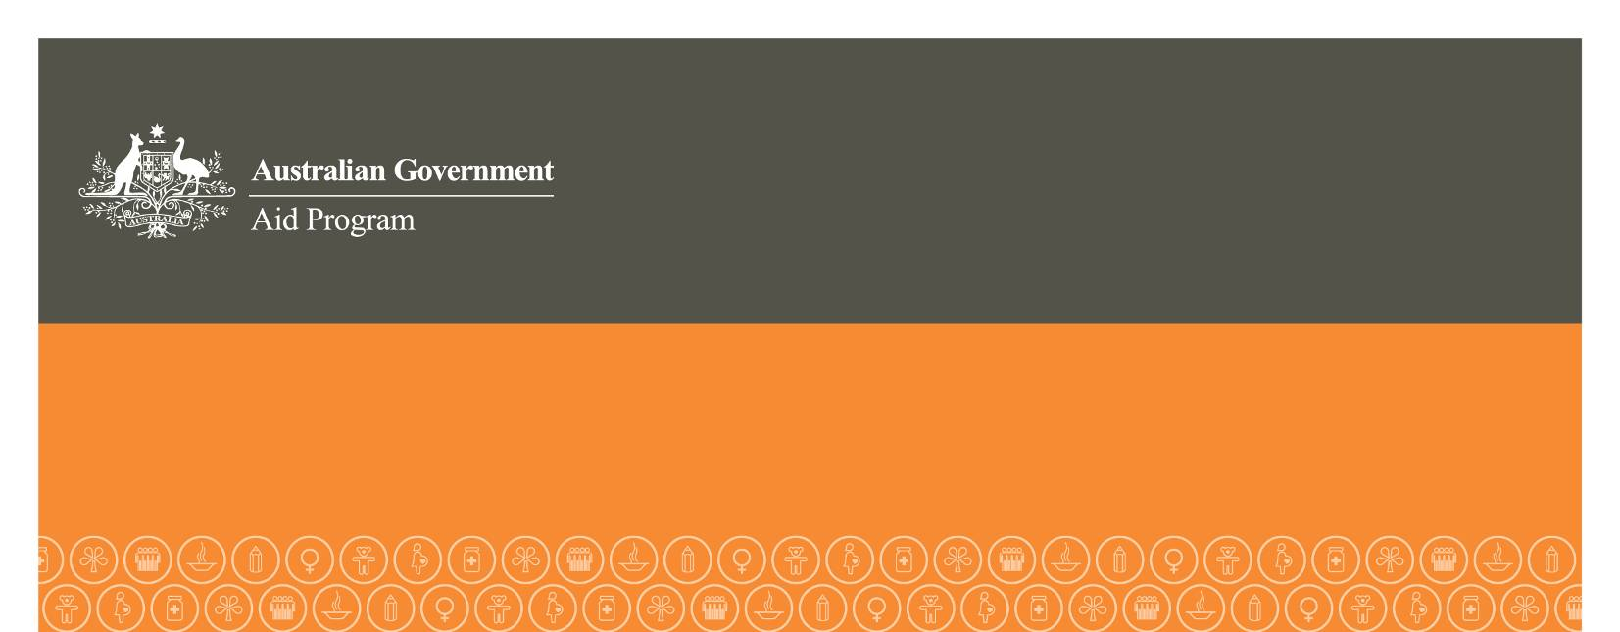
Attachment A: Expression of Interest

Instructions
This form is to be completed by the applicant organisation. The form must be typed and in English. The form must be received by the relevant Australian diplomatic mission by 4 pm (local time) 17 August 2012. The form can be mailed or delivered in person, but will not be accepted by e-mail. Late applications will not be accepted, without prior agreement from the relevant Australian diplomatic mission.
THIS FORM MUST BE NO LONGER THAN 2 PAGES
ORGANISATION AND PROJECT DETAILS (maximum 2 pages)
Name of organisation and address
Name of project
Need for and purpose of project (maximum 300 words)
Country in which project will be implemented
Amount of funding sought from HRGS (maximum AUD100,000)
Name of contact person
Contact numbers | Work Mobile
Email address

